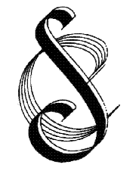 | Streatham Choral Society  Founded 1921  Registered Charity No. 802195
PAYING STAFF STATEMENT
Key details
Effective date | September 2016
Date of last review | February 2023
Reviewed by | Martin Gresty (Secretary)
Approved by Committee | March 2023
Next review date | February2024

The Society does not include any paid staff. Members of the choir are reimbursed if they have purchased items relating to choir activity. Travel costs are not reimbursed.

