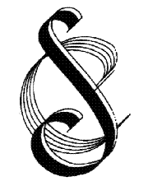 | Streatham Choral Society  Founded 1921  Registered Charity No. 802195

INVESTMENT STATEMENT
Key details
Effective date | September 2016
Date of last review | February 2023
Reviewed by | Martin Gresty (Secretary)
Approved by Committee | March 2023
Next review date | February 2024

Any income generated by the Society is paid into a standard bank account. The Society does not invest any income into investment funds.

